RELEASE
Contacts: Virginia Egg Council ~ 540 556 9958 ©, 540 345 3958, eggsrgr8@rev.net, www.virginiaeggcouncil.org/events
State Fair of Virginia ~ www.StateFairVa.org
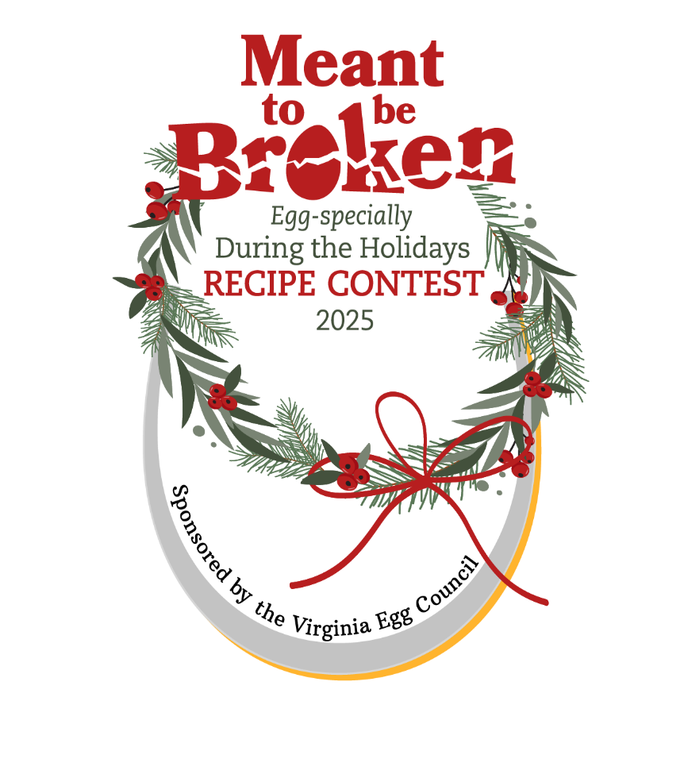
2025 Egg Recipe Contest at the County Fair

Everyone has a favorite recipe they love to whip up during the winter holidays – and we’re looking for the one you most enjoy preparing and serving. It doesn’t matter if the recipe is an appetizer, a main dish, a beverage, a dessert, or an item you fix for gifting, if it contains at least four eggs, you can enter it. The possibilities are endless, so we’re expecting Virginia’s eggceptional cooks and bakers to come up with something eggstraordinary – proving that Eggs are Meant to be Broken, Egg-specially during the holidays!
Interested contestants:
Contact your local county fair for details

Recipe Requirements
- The recipe must include a minimum of four eggs and be geared for holiday enjoyment.
- Ingredients must be listed in order of use, in the written recipe.
- Directions, cooking time & temp., pan type and size, and servings must be included.
- If toppings, frostings or fillings are used, those recipes must be included.
- Recipes will become the property of the Virginia Egg Council.
- Recipes will be prepared and presented for judging at local county fairs. *

Prizes at Local Fair Level
1st, 2nd and 3rd place winners will receive gift bags from the VA Egg Council and a chance to compete for top state honors at the State Fair of Virginia on Saturday, October 4, 2025.

Prizes at State Level
1st - $400 plus A Dozen Braswell Family Farms’ EB Eggs per week for a year!
2nd - $300 plus A Dozen Braswell Family Farms’ EB Eggs per week for six months!
3rd - $200 plus A Dozen Braswell Family Farms’ EB Eggs per week for six months!
Braswell Family Farms is Virginia’s supplier of Eggland’s Best Eggs, Nashville, NC

*No Competition at your Local Fair? You may compete at another county fair if their residency requirements allow it. Participant may place in one contest, one time.

