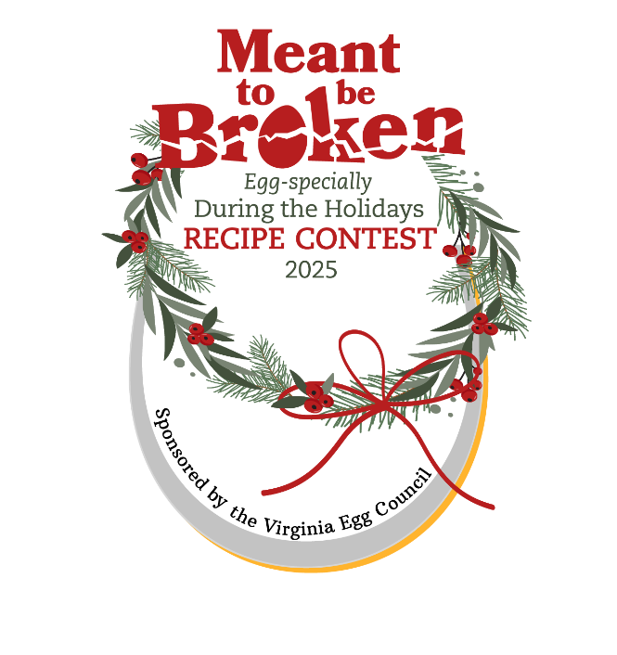
Local Fair Information

Prizes: Special gifts from the VA Egg Council will be sent to your top 3 winners, as soon as we get that information from you

Your top three winners are eligible to compete in the
State Finals at the State Fair of Virginia
October 4, 2025
Prizes at State Finals
1st - $400 & Eggs! ~ 2nd - $300 & Eggs! ~ 3rd - $200 & Eggs!
Rules:
- Open to any individual who is a Virginia resident; one entry per person at a given fair. Participant does not have to reside in county where fair is held. Local fairs are asked to waive residency requirements, if possible, but we understand if that won’t work. Participants may enter multiple contests around the state, however, should they place first, second or third, they may no longer compete in another local fair, representing that fair at the state finals.
- Entrant must prepare a recipe that would be appropriate for the winter holidays – either a beverage, a dessert, an appetizer, a main dish, or a gift item.
- A minimum of 4 large whole eggs must be used in the entered recipe.
- Safe food handling is the responsibility of the contestant and the fair. Contest organizers may deem a contestant in-eligible should the entry arrive at room temperature that should have been kept cold and not delivered in a cooler.
- Recipe must: list ingredients in order of use; include clear preparation instructions, cooking time and temperatures, pan size and yield, and use a minimum of 4 whole eggs. The legible recipe must be on one side of the page and must be submitted with prepared entry. The back of recipe must include the contestant’s name, address, phone and email address and the name of the item. Contestants must fill in a Participant Release Form, to be attached to the recipe.
Notes
- Your fair accepts any liability if the entries are served to the public.
- Fairs need to ensure safe food handling procedures (ex.: Cold items served out of coolers).
- Have competitors sign Release Forms and send to us along with their recipes.
- A sample judging form is available on www.virginiaeggcouncil.org. Modifications may be made.
- Fairs will determine whether to share judges’ forms with participants.
- This is an adult competition – contestants under age 18 will be judged as adults.
- Recipes will become the property of the Virginia Egg Council.

Winners’ Information and recipes must be submitted to the VA Egg Council
Send Winners Information Form and TOP THREE winning recipes to the VA Egg Council as soon as judging is complete. This is especially important for any fairs’ competitions held in September. We will send special gifts to your winners and at the beginning of September, will send Contest Finals information to your winners. Although it’s not essential to send additional entries, we’d love to have them, as well.

Finals Judging will be based on: Flavor / Creativity / Texture / Appearance / Appropriateness of ingredients for recipe / and Recipe requirements filled.

VA Egg Council ~ Contact: Mary Rapoport ~ 540 556 9958 © 540 345 3958 ~ eggsrgr8@rev.net

