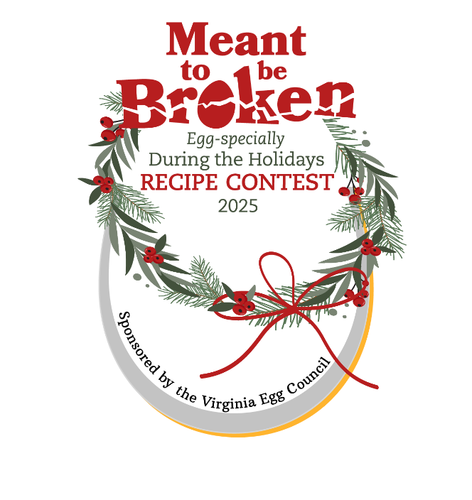
County Fair Sign Up Form S

Return completed form by
June 15, 2025
Send to eggsrgr8@rev.net or
VA Egg Council
3401 West Ridge Rd.
Roanoke, VA 24014

Name of Fair______________________________ County __________________

Fair Dates: ____________

Contest Organizer’s Name___________________________________

Organizer’s Email __________________________Phone__________________

We will hold the Meant to be Broken Egg-specially During the Holidays Recipe Contest on: Date ______

To enable the Virginia Egg Council to offer this contest, details about its success in your county and efficient information management are required.
Please help us by agreeing to the following:
I Will:

____ Send all the competing recipes & participants’ information to VA Egg Council.
____ Send Winner’s Information Forms and their winning recipes to VA Egg Council.
____ Forward any newspaper articles, along with the date and name of the publication that mentions the contest or possibly prints the winning recipes.
____ Remind winners that they will receive gifts directly from us and we will reach out to them about the Meant to be Broken Egg-specially During the Holidays contest state finals.
____ Supply ribbons if they are to be presented to winners.

__________________________________________________________________
(County Fair Contest Contact’s Signature) Date

